Exercise: Storage

Kubernetes is a free and open-source container orchestration platform. It provides services and management capabilities needed to efficiently deploy, operate, and scale containers in a cloud or cluster environment. When managing containerized environments, Kubernetes storage is useful for storage administrators, because it allows them to maintain multiple forms of persistent and non-persistent data in a Kubernetes cluster. This makes it possible to create dynamic storage resources that can serve different types of applications.

Practice 1: Direct provisioning of Azure File storage

Note: Try not to do a copy/paste on commands requests unless you are instructed to do so. Copy/paste will not help you to learn Kubernetes!

1. Login to Azure and connect to your AKS cluster.

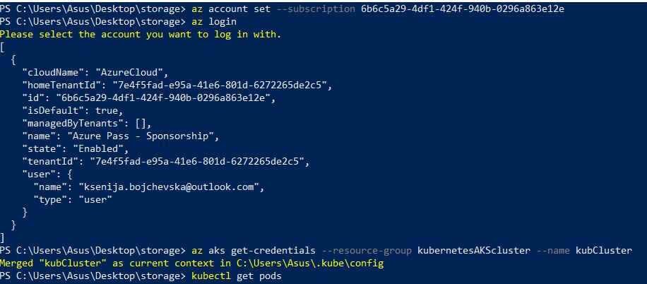

1. Check if any pods run under the default namespace if so delete everything under the default namespace.

Run the command kubectl get pods

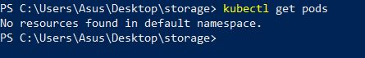

3. In this practice we will directly provision Azure Files to a pod running inside AKS.

4. First create the Azure Files share. Run the following commands:

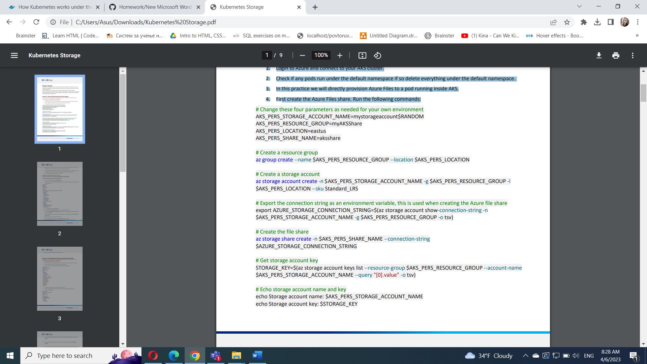

$AKS_PERS_STORAGE_ACCOUNT_NAME=”aksclusterstorage”

$AKS_PERS_RESOURCE_GROUP=”rgrouptest”

$AKS_PERS_LOCATION=”eastus”

$AKS_PERS_SHARE_NAME=”akscluster”

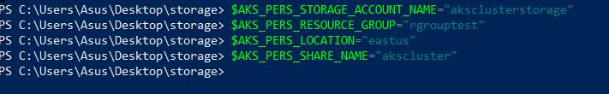

az group create --name $AKS_PERS_RESOURCE_GROUP --location $AKS_PERS_LOCATION

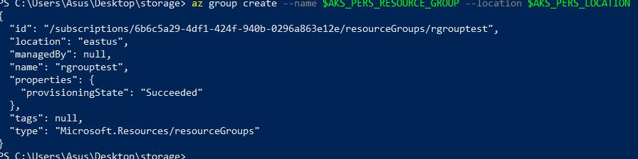az storage account create -n $AKS_PERS_STORAGE_ACCOUNT_NAME -g $AKS_PERS_RESOURCE_GROUP -l $AKS_PERS_LOCATION --sku Standard_LRS

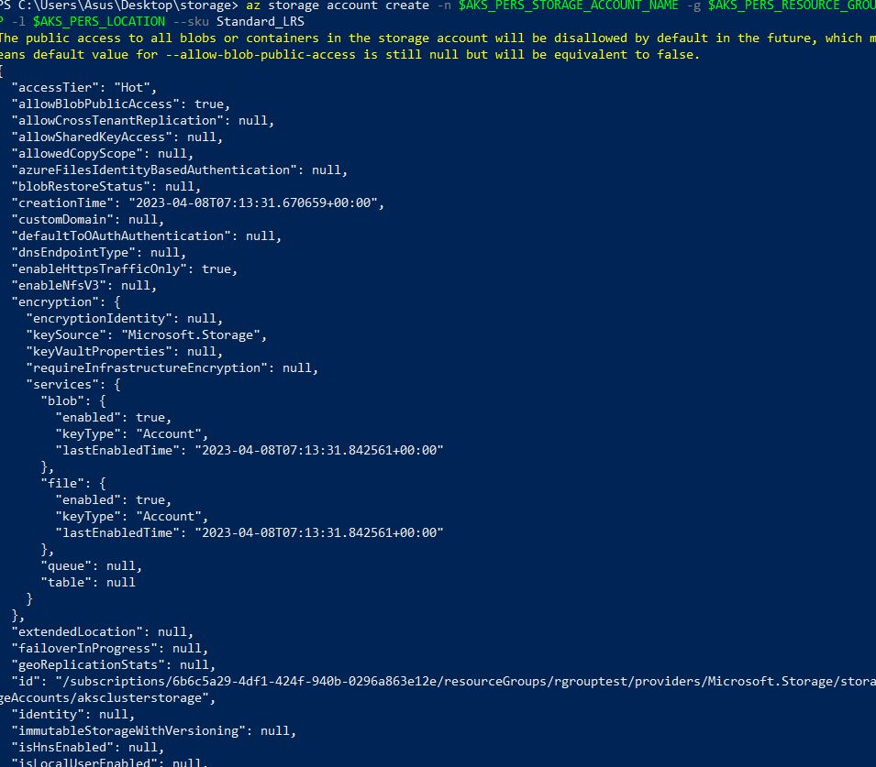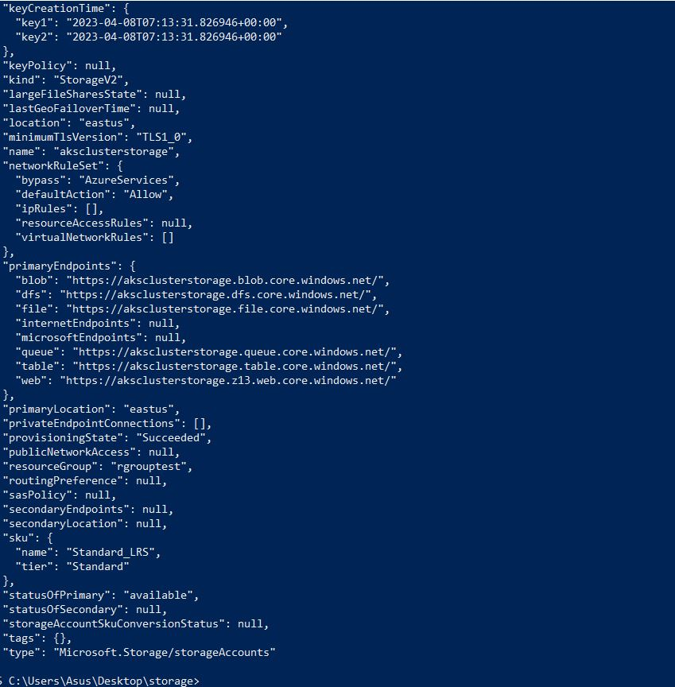

export AZURE_STORAGE_CONNECTION_STRING=$(az storage account show-connection-string -n $AKS_PERS_STORAGE_ACCOUNT_NAME -g $AKS_PERS_RESOURCE_GROUP -o tsv)



az storage share create -n $AKS_PERS_SHARE_NAME --connection-string $AZURE_STORAGE_CONNECTION_STRING

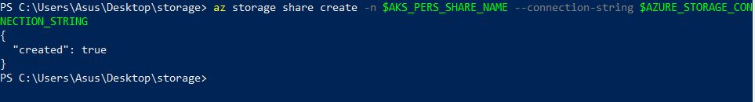

STORAGE_KEY=$(az storage account keys list --resource-group $AKS_PERS_RESOURCE_GROUP --account-name $AKS_PERS_STORAGE_ACCOUNT_NAME --query "[0].value" -o tsv)



echo Storage account name: $AKS_PERS_STORAGE_ACCOUNT_NAME

echo Storage account key: $STORAGE_KEY

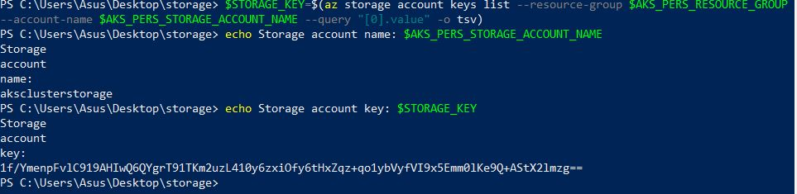

5. Make a note of the storage account name and key shown at the end of the script output. These values are needed when you create the Kubernetes volume in one of the following steps.

6. Now we will need to create a Kubernetes secret that will be used to mount the Az File Share to the pod. You need to hide this information from the pod’s definition and K8S secret is the best way to do it.

7. Run the following (single) command to create the secret:

kubectl create secret generic azure-secret --from- \

literal=azurestorageaccountname=$AKS_PERS_STORAGE_ACCOUNT_NAME \

--from-literal=azurestorageaccountkey=$STORAGE_KEY



8. Check if secret was created. Run kubectl get secret -A.

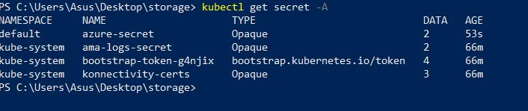

9. Now we can create the pod and mount the Azure File. Create a new file named azure-files-pod.yaml with the following contents:

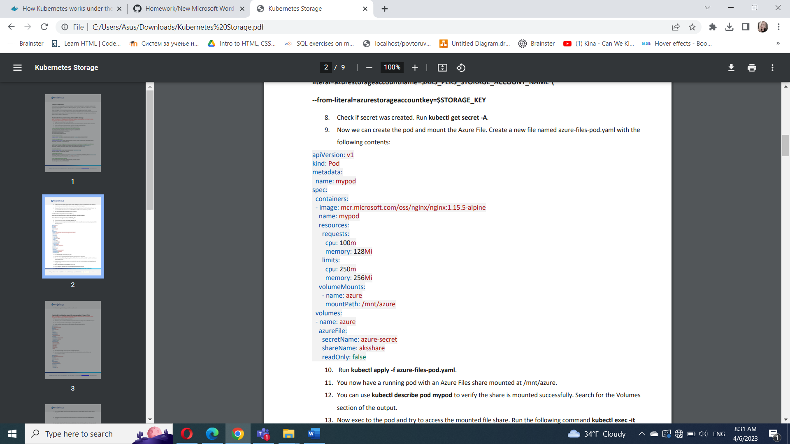

10. Run kubectl apply -f azure-files-pod.yaml

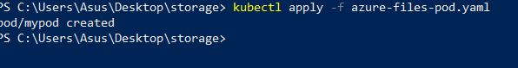

11. You now have a running pod with an Azure Files share mounted at /mnt/azure.

12. You can use kubectl describe pod mypod to verify the share is mounted successfully. Search for the Volumes section of the output.

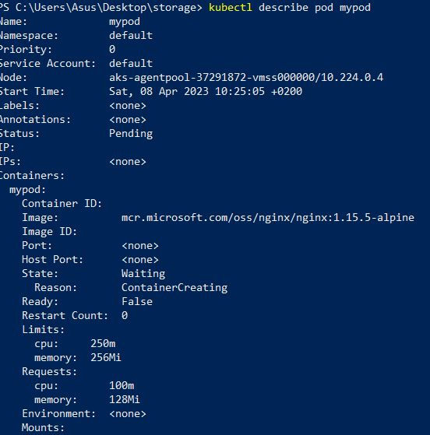

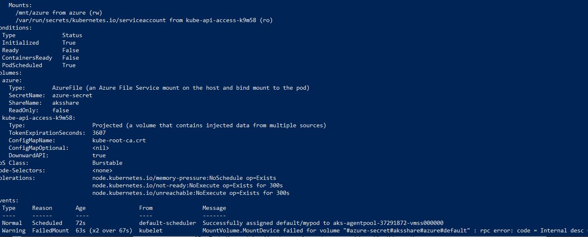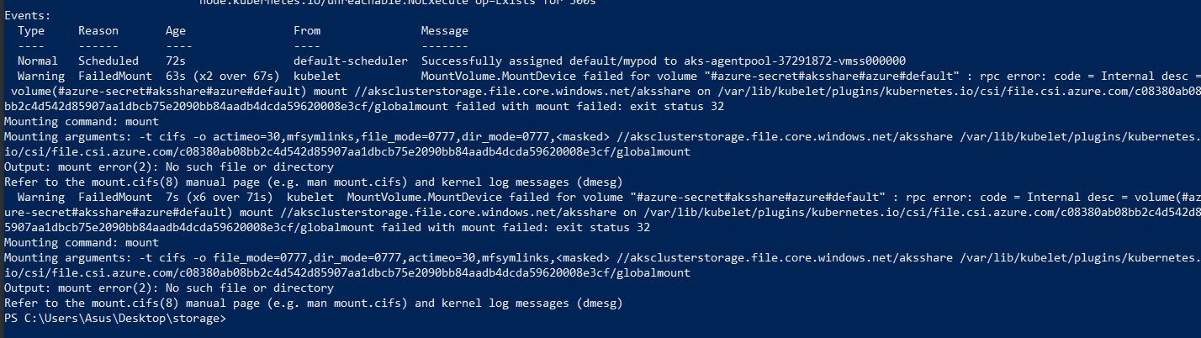

13. Now exec to the pod and try to access the mounted file share. Run the following command kubectl exec -it mypod – bash

14. Go to /mnt/azure and create a blank file test.txt file.

15. Go to the portal and locate your Azure storage provisioned for this practice.

16. Under the Files section, check the contents of the Azure file share and check if test.txt file exists

17. Delete the mypod. What happens to the Azure File share?



Practice 2: Provisioning Azure File storage using PVs and PVCs Note: Try not to do a copy/paste on commands requests unless you are instructed to do so. Copy/paste will not help you to learn Kubernetes!

1. Login to Azure and connect to your AKS cluster.

2. Check if any pods run under the default namespace if so delete everything under the default namespace.



3. Now we will provision Azure files storage to a pod using PV and PVC.

4. Create a azurefile-mount-options-pv.yaml file with a PersistentVolume like this:

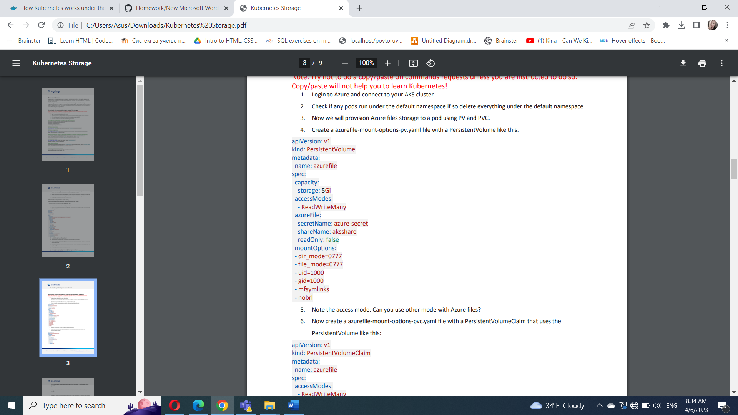

5. Note the access mode. Can you use other mode with Azure files?

ReadWriteOnce , ReadOnlyMany , ReadWriteMany

6. Now create a azurefile-mount-options-pvc.yaml file with a PersistentVolumeClaim that uses the PersistentVolume like this:

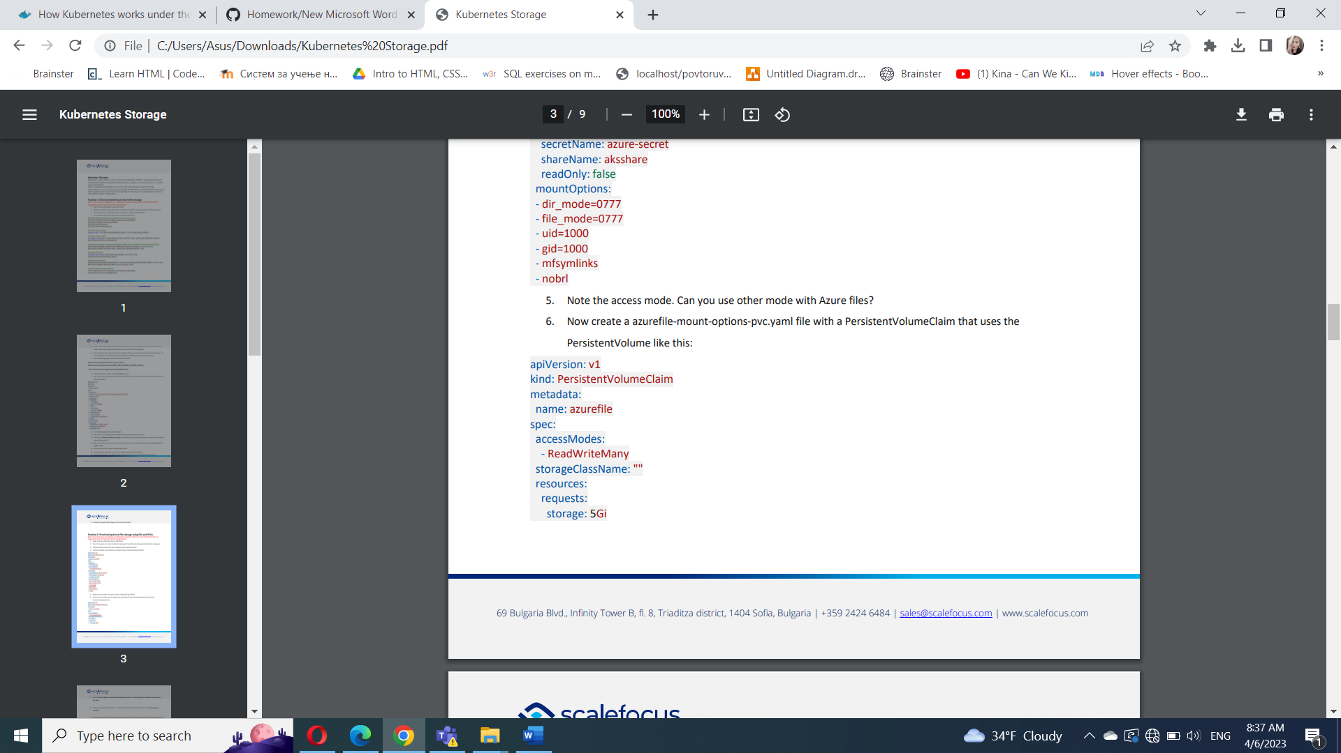

7. Execute kubectl apply -f azurefile-mount-options-pv.yaml and kubectl apply -f azurefile-mount-optionspvc.yaml.





8. Verify your PersistentVolumeClaim is created and bound to the PersistentVolume. Run kubectl get pvc azurefile.

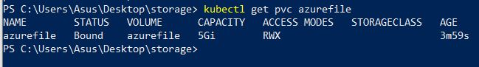

9. Now we can embed the PVC info inside our pod definition. Create the following file azure-files-pod.yaml with following content:

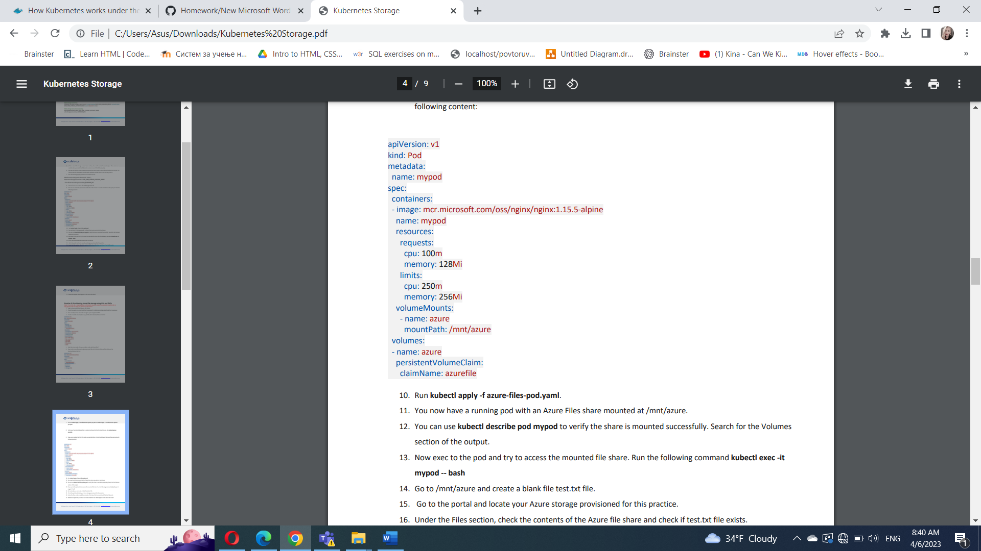

10. Run kubectl apply -f azure-files-pod.yaml.

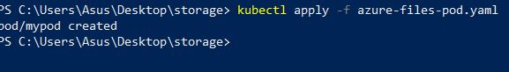

11. You now have a running pod with an Azure Files share mounted at /mnt/azure.

12. You can use kubectl describe pod mypod to verify the share is mounted successfully. Search for the Volumes section of the output.

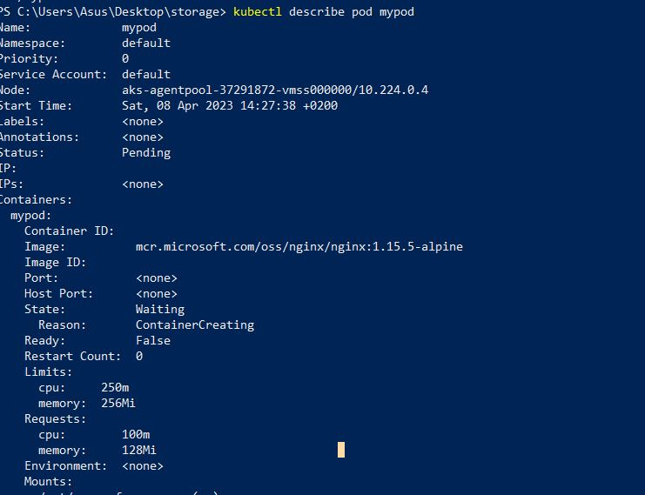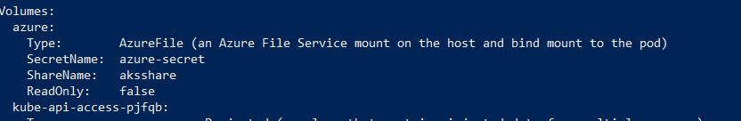

13. Now exec to the pod and try to access the mounted file share. Run the following command kubectl exec -it mypod – bash

14. Go to /mnt/azure and create a blank file test.txt file.

15. Go to the portal and locate your Azure storage provisioned for this practice.

16. Under the Files section, check the contents of the Azure file share and check if test.txt file exists.

17. Delete the mypod the pv and pvc you have created so far. What happens to the Azure File share?

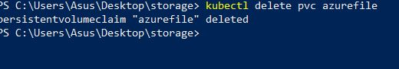

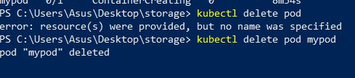

Practice 3: Provisioning Azure file storage using Storage Classes

Note: Try not to do a copy/paste on commands requests unless you are instructed to do so. Copy/paste will not help you to learn Kubernetes!

1. Login to Azure and connect to your AKS cluster.

2. Check if any pods run under the default namespace if so delete everything under the default namespace.



3. Now we will provision file storage using the definition of storage classes. Create a file named azure-file-sc.yaml and copy in the following example manifest:

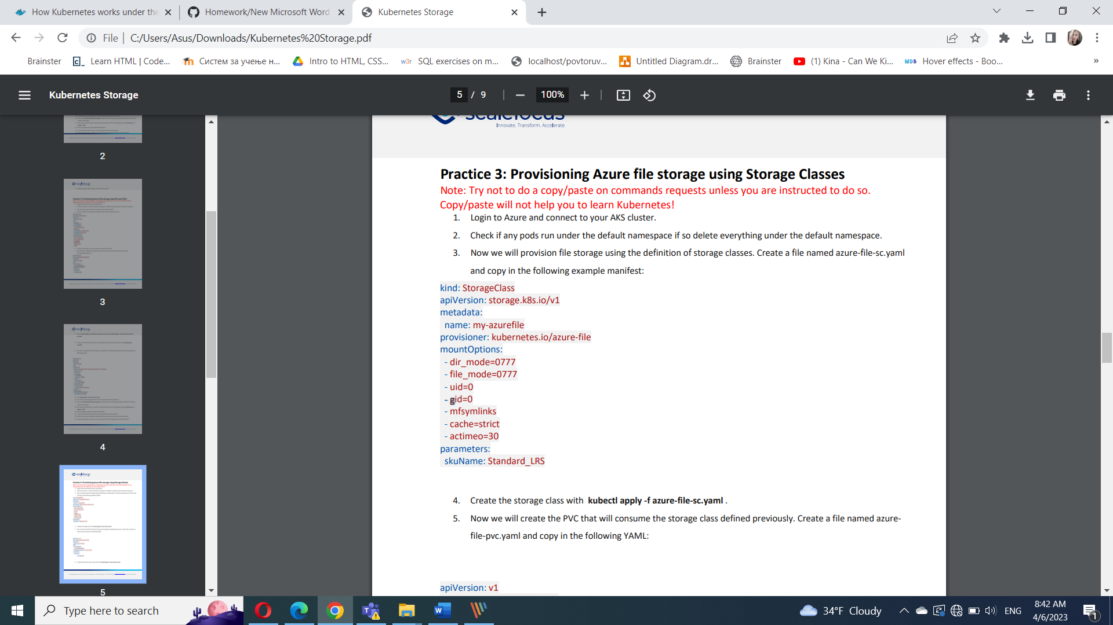

1. Create the storage class with kubectl apply -f azure-file-sc.yaml .

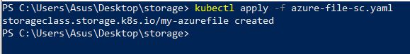

4. Now we will create the PVC that will consume the storage class defined previously. Create a file named azurefile-pvc.yaml and copy in the following YAML:

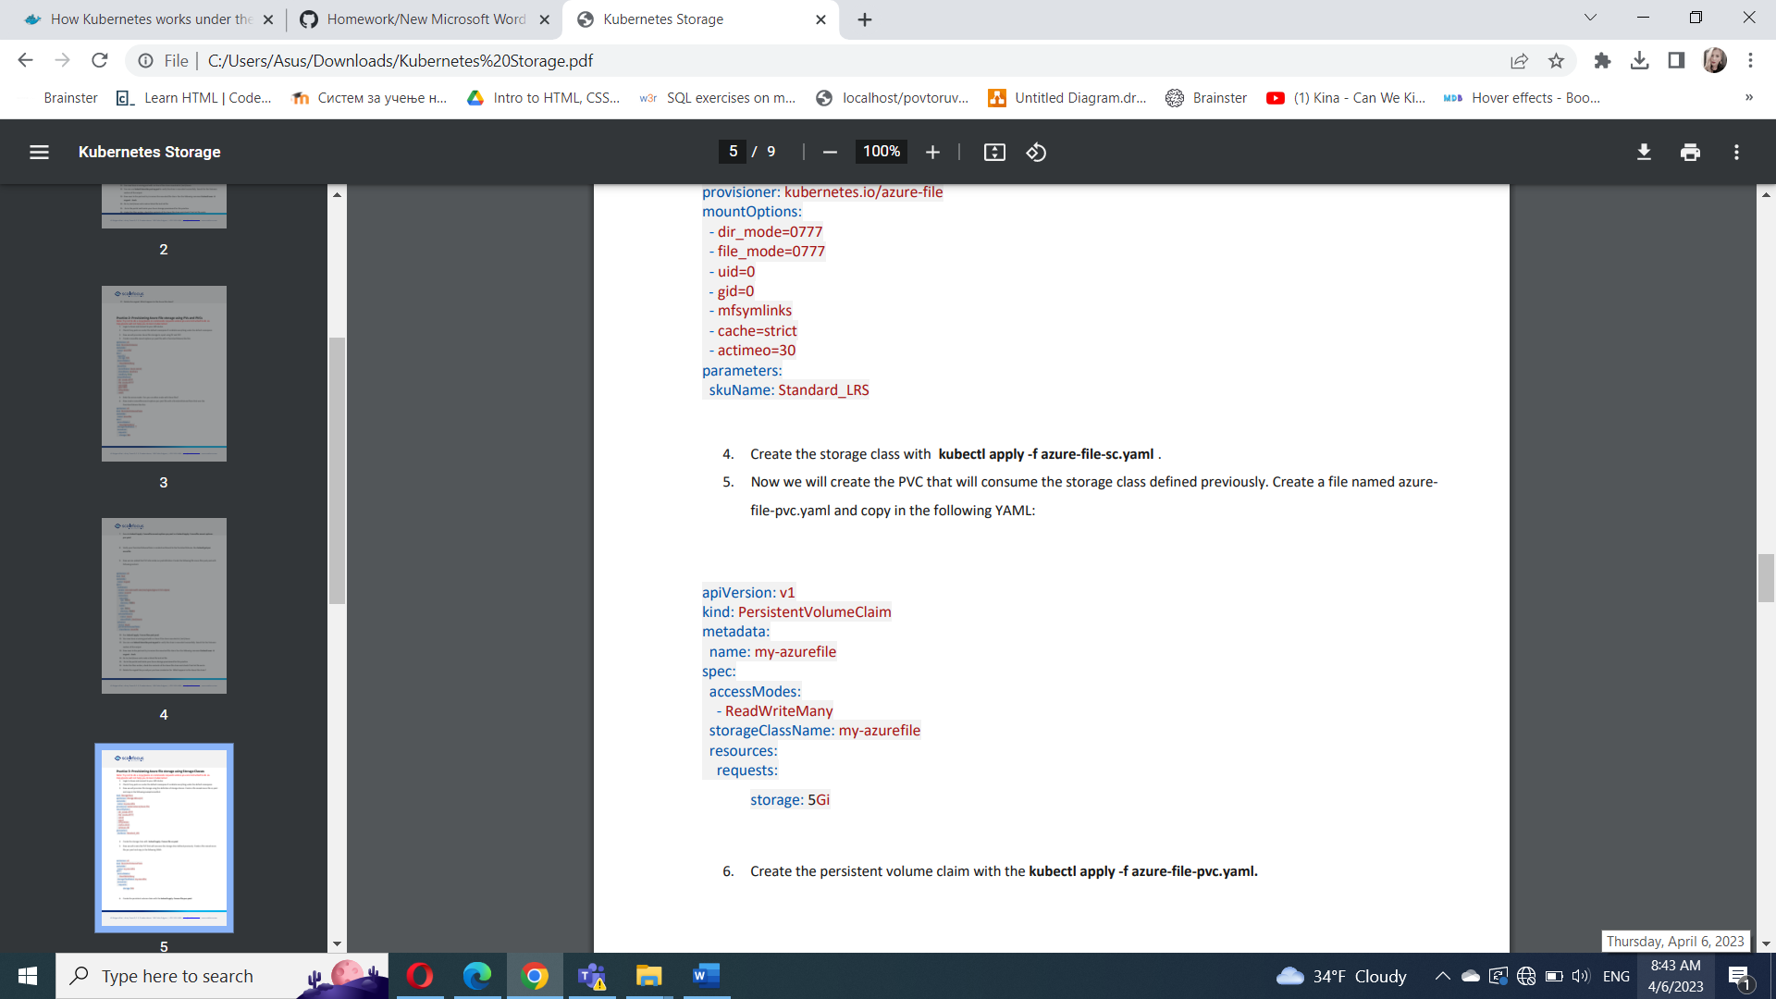

6. Create the persistent volume claim with the kubectl apply -f azure-file-pvc.yaml.

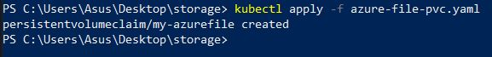

7. Once completed, the file share will be created. A Kubernetes secret is also created that includes connection information and credentials. You can use the kubectl get pvc my-azurefile command to view the status of the PVC.

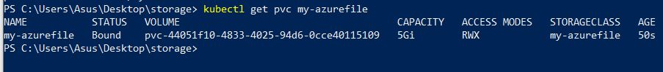

8. Now we will create the pod that consumes the PVC. Create a file named azure-pvc-files.yaml, and copy in the following YAML. Make sure that the claimName matches the PVC created in the last step:

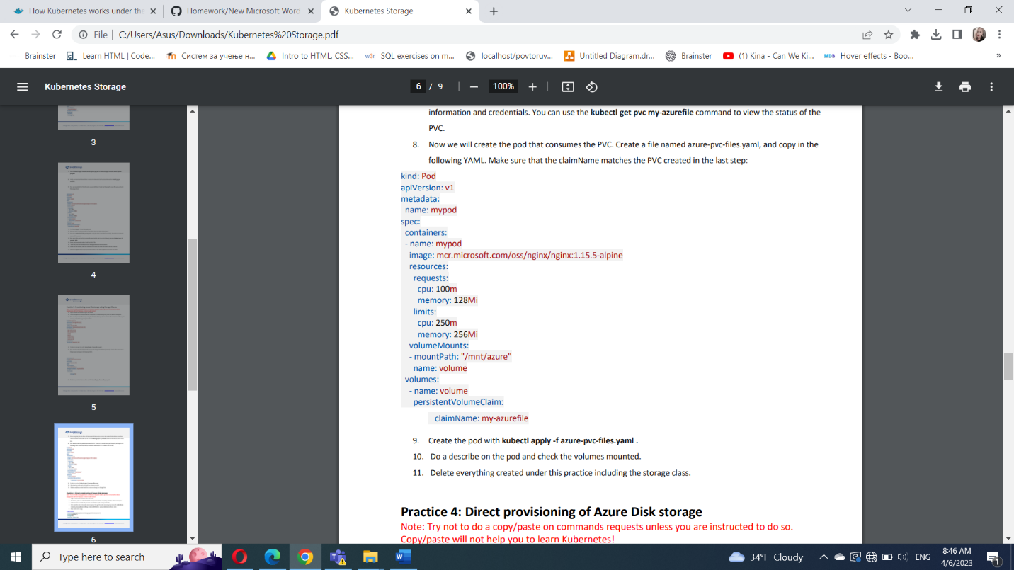

9. Create the pod with kubectl apply -f azure-pvc-files.yaml .

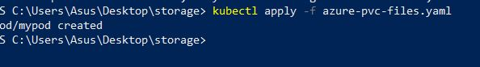

10. Do a describe on the pod and check the volumes mounted.

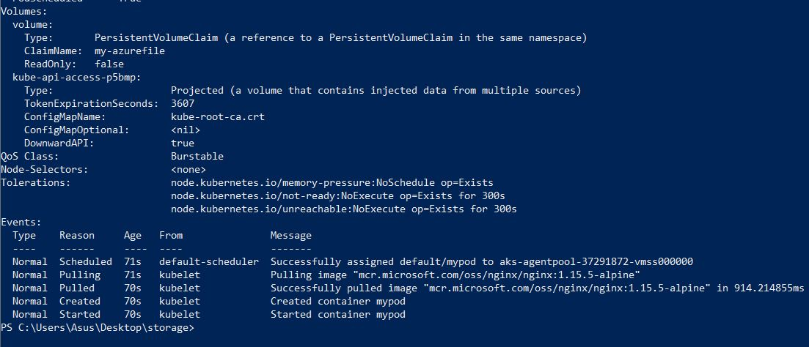

11. Delete everything created under this practice including the storage class.

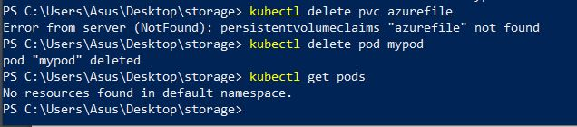

Practice 4: Direct provisioning of Azure Disk storage

Note: Try not to do a copy/paste on commands requests unless you are instructed to do so. Copy/paste will not help you to learn Kubernetes!

1. Login to Azure and connect to your AKS cluster.

2. Check if any pods run under the default namespace if so delete everything under the default namespace.

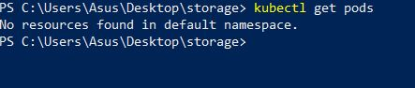

3. In this practice we will directly provision Azure Disk to a pod running inside AKS.

4. First create the disk in the node resource group. First, get the node resource group name with az aks show -- resource-group myResourceGroup --name myAKSCluster --query nodeResourceGroup -o tsv .

az aks show --resource-group rgrouptest --name akscluster --query nodeResourceGroup -o tsv

az aks show --resource-group rgrouptest --name akscluster --query nodeResourceGroup -o tsv MC_ rgrouptest_akscluster_eastus



5. Now create a disk using:

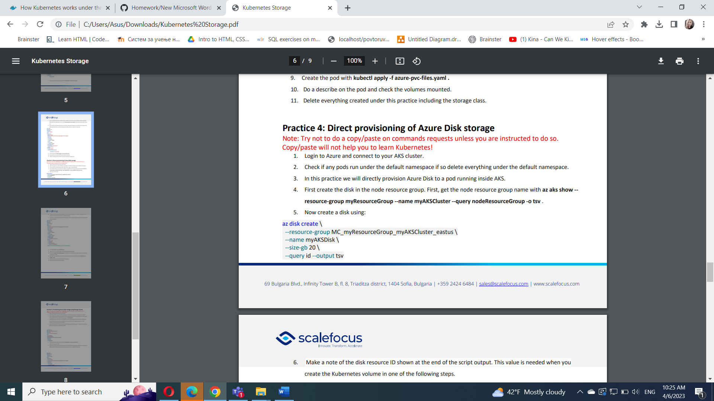



6. Make a note of the disk resource ID shown at the end of the script output. This value is needed when you create the Kubernetes volume in one of the following steps.

7. Now we can create the pod and mount the Azure Disk. Create a new file named azure-disk-pod.yaml with the following contents:

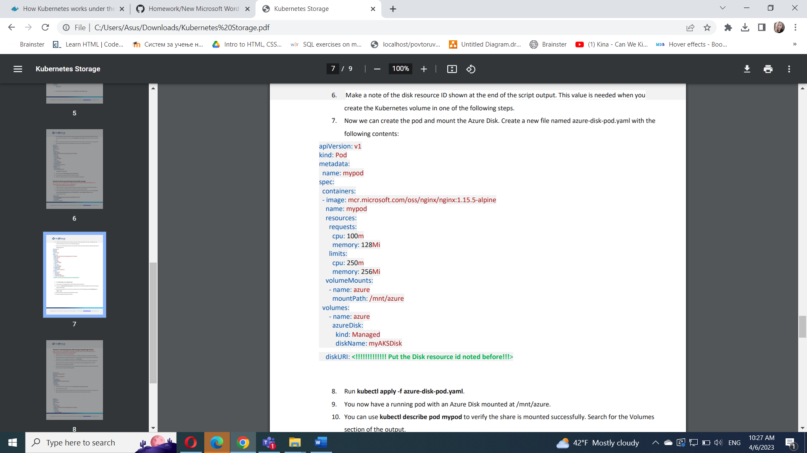

8. Run kubectl apply -f azure-disk-pod.yaml.

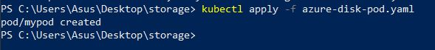

9. You now have a running pod with an Azure Disk mounted at /mnt/azure.

10. You can use kubectl describe pod mypod to verify the share is mounted successfully. Search for the Volumes section of the output.

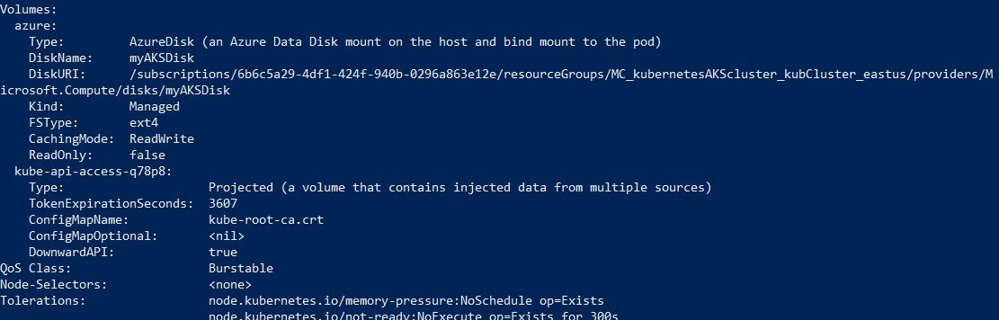

11. Now exec to the pod and try to access the mounted volume. Run the following command kubectl exec -it mypod – bash

12. Go to /mnt/azure and try create a blank file test.txt file. 13. Delete everything created by this practice.



Practice 5: Provisioning Azure Disk storage using Storage Classes

Note: Try not to do a copy/paste on commands requests unless you are instructed to do so. Copy/paste will not help you to learn Kubernetes!

1. Login to Azure and connect to your AKS cluster.

2. Check if any pods run under the default namespace if so delete everything under the default namespace.



1. Now we will provision Azure disk and attach it to a running pod but this time using dynamic provisioning with storage classes. List the available storage classes, run kubectl get sc.

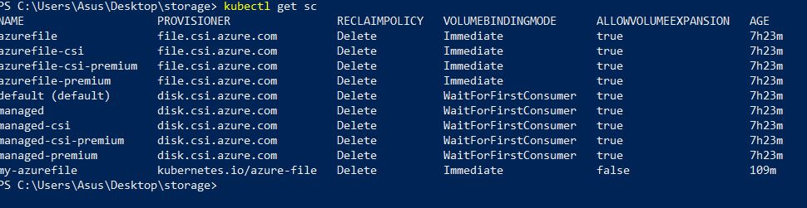

4. Examine the output. Each AKS cluster includes four pre-created storage classes, two of them configured to work with Azure disks, default and managed-premium. We will use the managed-premium in our PVC definition since it uses premium type of disks.

5. Now we will create the PVC that will consume the storage class defined previously. Create a file named azurepremium.yaml and copy in the following YAML:

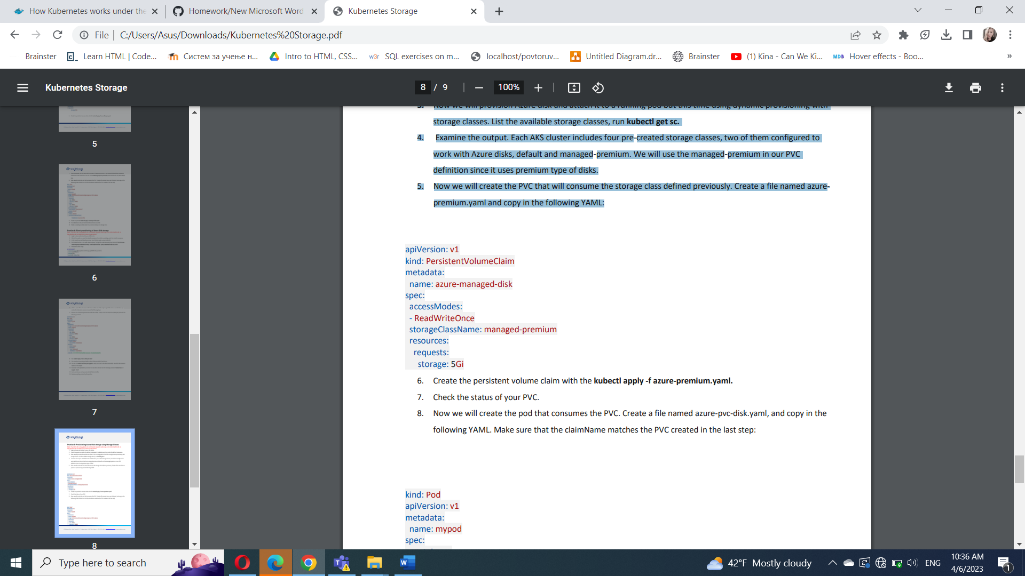

1. Create the persistent volume claim with the kubectl apply -f azure-premium.yaml.



1. Check the status of your PVC.

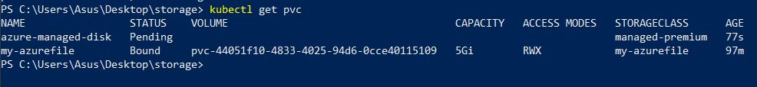

8. Now we will create the pod that consumes the PVC. Create a file named azure-pvc-disk.yaml, and copy in the following YAML. Make sure that the claimName matches the PVC created in the last step:

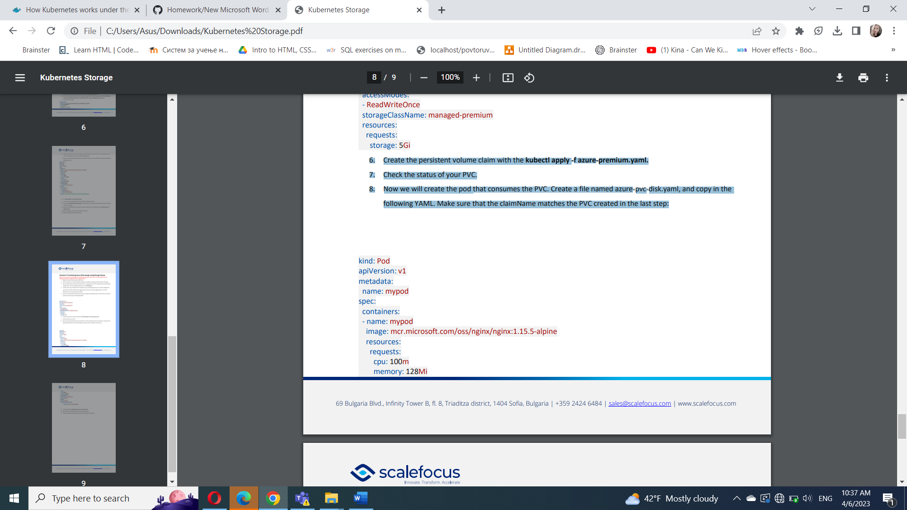

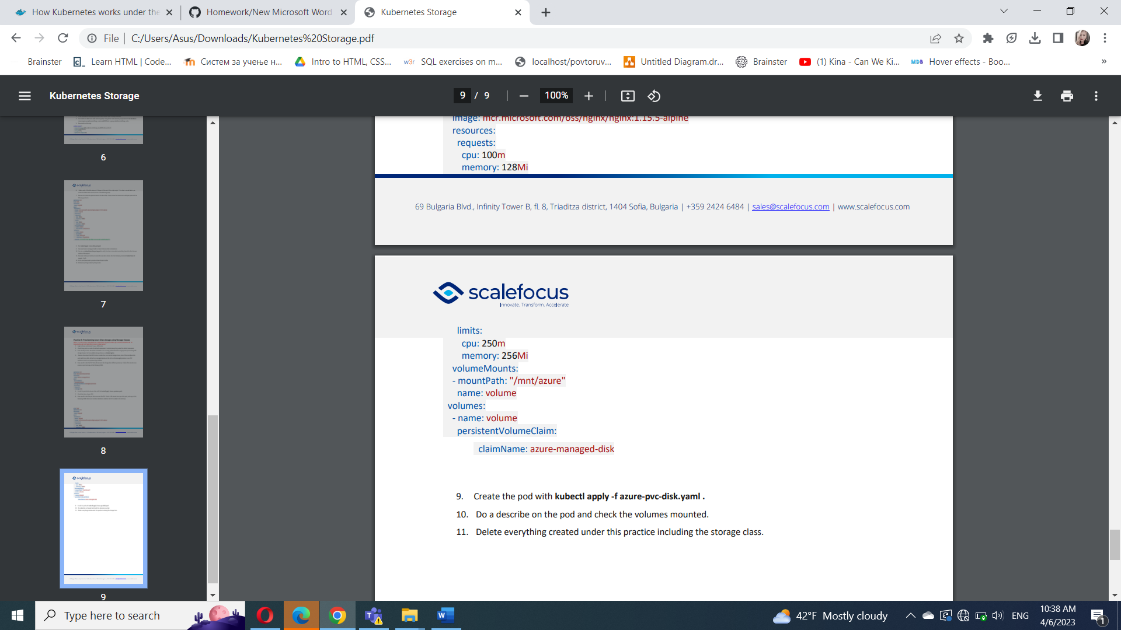

9. Create the pod with kubectl apply -f azure-pvc-disk.yaml .

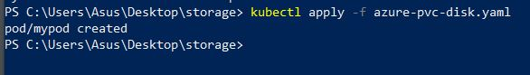

10. Do a describe on the pod and check the volumes mounted.

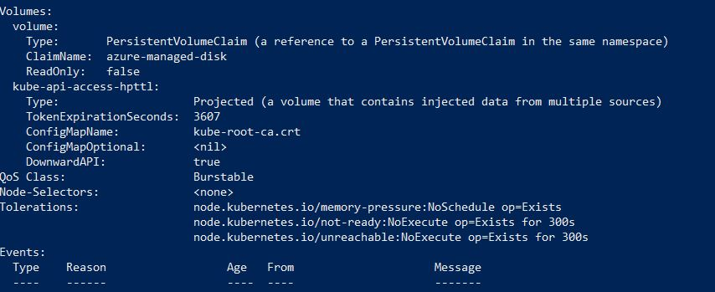

11. Delete everything created under this practice including the storage class.

